
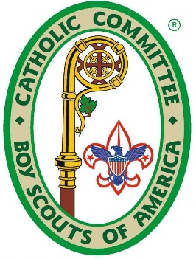
2026 St. George Trek
Philmont Scout Ranch
Cimarron, New Mexico
July 1 – July 18, 2026

Participant Application*
Archdiocese of Los Angeles
(*please note that this form is only to apply to the Archdiocese Committee to be selected for one of our allocated spots. If selected by us, we will submit an approval for you to NCCS and give you instructions on applying to NCCS to actually register for the Trek)

Participant
Name:
Street Address:
City: |  |  |  |  |  |  | State: |  | CA |  | ZIP:
Email: |  |  |  |  |  |  |  | Home Phone:
Date of Birth: |  |  |  |  |  |  |  | Male |  |  |  | Female
Parents
Father |  |  | Email: |  |  | Cell Phone:
Mother |  |  | Email: |  |  | Cell Phone:

Scouting Biography
Unit |  |  | High Adventure
Unit Type: Unit Num: |  |  | High Adventure Experience:  (List below)
Council:
Leadership Positions Held:
(List below)
 |  |  | # Previous Philmont Treks:
Other Scouting Activities  (List activities below) |  |  | Catholic Scouting Activities  (Retreats, pilgrimages, hikes, bike rides, etc.)
Certifications  Check if applicable. |  |  | Religious Emblems Earned  Check all that apply.
  I am certified in Wilderness First Aid and my certification is valid through July 2026.
  I am certified in CPR and my certification is valid through July 2026
  Light of Christ
  Parvuli De
  Ad Altare Dei
  Pope Pius XII

Parish Information
Parish Name: |  | City:
Pastor Name:

Please list any parish activities you are or have participated in (altar server, lector, etc.):

School Information
School Name: |  | City:
Grade for 2026-27 school year (must be currently in High School):

School Honors | School Activities
(List below) | (List below)

Affirmation of Pre-requisites | Philmont Weight Requirements
Please affirm that you accept these requirements
I meet or will meet the Philmont height/weight requirements as detailed here.
I understand that I must be validly certified in CPR by July 2026.
I understand that I must attempt to be validly certified in Wilderness First Aid by July 2026.
I am willing to participate in activities and discussions about discernment of vocation to priesthood or religious life.
I understand that acceptance must be confirmed by the National Director of the Trek.
I understand my participation is contingent on the completion of payments and the submission of all required documents.

Essay question:
On a separate sheet of paper and in no less than 100 words, explain why you wish to represent your archdiocese as a St. George Trek participant.

Please submit this form no later than October 12, 2025 via email to mab4swim@aol.com or mail to:
CCSALA St. George Trek
c/o Maureen Brown
5412 Abbott Place
Los Angeles, CA 90042

